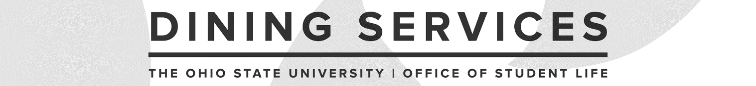

Assistant Dining Manager Interview Guide
Updated May 2021

Candidate: ___________________________ Date: ______________

Interviewer: _________________________________________ Operation: ______________

Introduction
Interview panel should start by introducing themselves (share pronouns, if comfortable) and sharing their title and how they interact with this position. Interview lead should then share the following with the candidate:

We are excited to be speaking with you further about your interest in the Assistant Dining Manager role. Today, our questions will focus more holistically on the varying aspects of this position. We have up to 50 minutes for your interview today. You are welcome to ask us to repeat any question and there will be time at the end for you to ask any questions. We will be taking notes as you talk, so pardon our pauses as we go through the interview.

Interview Questions

Staff Supervision
- Working and supervising a team can sometimes be challenging. Tell me about a time when you have experienced a challenging moment while working with a team? How did you manage the challenge at hand?

- Please tell us about a time you had to have a difficult conversation with an employee.

- Share a time you were responsible building a diverse team. How did you accomplish this task?
Communication & Teamwork
- Sometimes you will encounter a task or decision in which other employees from your team will need to be involved. Can you please tell me about a time where you were on a team and had to involve other team members in your actions or decisions?
- Sometimes, distributing the workload among multiple people can be challenging. Describe a situation in which you were skillful in crafting a plan that distributed the workload appropriately. How did you determine the distribution? To what extent did you have to adjust your initial plan? What were the results?
- Policies and procedures can change to meet guests’ and students’ needs. Please share a time when it was important to communicate changes in policies or expectations to an individual or group in a way that minimized ambiguity. To whom did you communicate responsibilities? What approach did you use to prevent ambiguity and ensure that the person(s) understood what was expected? What was the result?

Customer Service
- Please describe a time you experienced extraordinary customer service.
- Sometimes, even the good customers can make unreasonable demands. Please give us an example of a time where you were unable to meet a customer’s demand. How do you handle the situation and what was the outcome?

Time Management/Organization
- All of us must multitask at times. Please describe a situation or period of time in which you were most challenged with handling multiple tasks simultaneously. What were the tasks and how did you handle them? What were the results?
- Please tell us about a time when you did a poor job of delegating.

Operation-Specific
- Please add 1-2 questions that are specific to the operation that you would like to ask.

Wellness
- An Assistant Dining Manager must be able to manage multiple competing priorities. How do you keep motivated through stressful times?

- Many of our staff members engage in various practices to maintain a sense of well-being; anything from walking to meditation. How would you role-model and promote a culture of well-being among your team?

Interview Wrap-Up

- What questions do you have about this position?

Wrap-Up
- Explain to the candidate next steps in the selection process and timeframe for making a decision.
- Provide candidate with a contact name and e-mail address/phone # for any follow-up questions.
- Thank the candidate for their time.

To be completed by the interviewer(s):

Overall Feedback/Notes:

Recommendation:

____ Recommend for hire
____ Recommend with reservations
____ Do not recommend

